**Matthew Rand - MSE 551 HW 2**

**HW#2 Due:09/12/2017**

1. Calculate the Energy vs. distance of two atoms using the LJ potentials we used in the class.

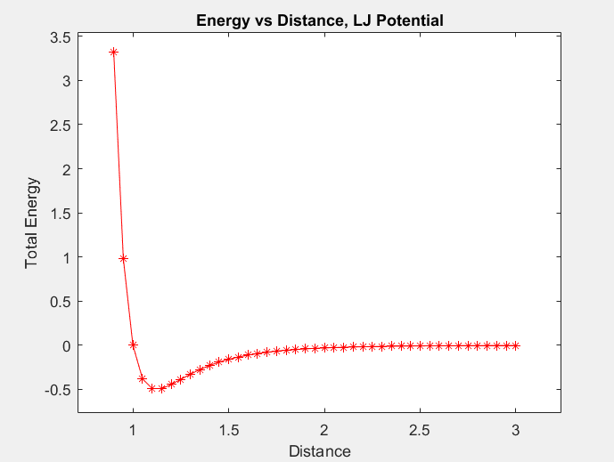

1. Calculate minimum Energy and lattice parameter for Al using the eam potential for the following structures:
2. SC
   1. **Minimum energy: -3.06 eV**
   2. **Lattice Constant: 2.69 A**
3. BCC
   1. **Minimum energy: -6.60 eV**
   2. **Lattice Constant: 3.22 A**
4. FCC
   1. **Minimum energy: -13.27 eV**
   2. **Lattice Constant: 4.05 A**

Compare and comment on the result.

1. **The FCC lattice has the lowest energy, meaning it is the most energetically favorable formation. This is in line with what we know about Aluminum: it favors a FCC crystal structure. The lattice constant is higher in FCC than BCC or SC because there are more atoms (4) per unit cell in FCC crystal structure.**
2. Calculate Energy vs. Volume curve for Al FCC structure using the eam potential. Then estimate the bulk modulus.

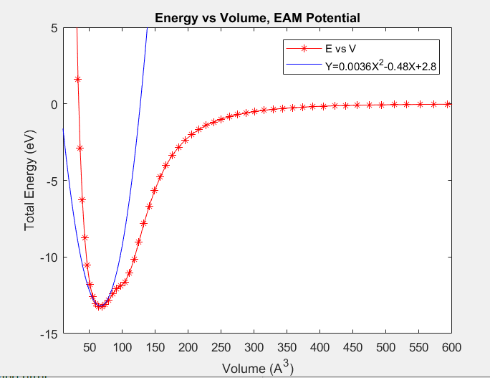

**Bulk Modulus: Y’’ = 0.0072, Volume at min energy = 66.4 A^3**

**E= 0.47 eV/A^3**

**E=76.6 GPa**

1. Brief summary of your class project.
   1. **My project will focus on simulation of a composite material of Graphene Oxide and Geopolymer using Molecular Dynamics in Lammps. Specifically, the simulations will focus on analyzing the mechanical properties of the composite with variable compositions, as well as analyzing interface interaction between graphene oxide and geopolymer. Key elements of this project involve creating stable GO and Geopolymer base simulations, and also finding/altering and appropriate interatomic potential file for the forces at the composite interface.**